BI ASSIGNMENT-2
Name: PUGALMANI K
Reg no: 1P25CS013
Class: 1st M.SC <COMPUTER SCIENCE>

- What is a Data Warehouse and discuss about the need of ETL?

Data Warehouse:
A Data Warehouse is a centralized repository used to store large volumes of structured, historical data collected from multiple sources such as databases, applications, and external systems. It is designed specifically for analysis, reporting, and decision-making, not for day-to-day transaction processing.
Key characteristics of a Data Warehouse:
- Subject-oriented – Organized around key business subjects (sales, finance, customers).
- Integrated – Data from different sources is standardized and combined.
- Time-variant – Stores historical data over long periods.
- Non-volatile – Data is stable and not frequently updated or deleted.
A data warehouse supports tools like OLAP, data mining, dashboards, and business intelligence (BI) applications.

Need for ETL (Extract, Transform, Load)
ETL is the process used to move data from source systems into a data warehouse in a usable and consistent format.
- Extract
  - Data is collected from various source systems (databases, files, APIs, ERP, CRM).
  - Sources may use different formats, structures, and technologies.
- Transform
  - Data is cleaned (remove duplicates, handle missing values).
  - Data is converted into a common format.
  - Business rules are applied (calculations, aggregations).
  - Data quality and consistency are ensured.
- Load
  - Transformed data is loaded into the data warehouse.
  - Can be done periodically (daily, weekly) or in real-time.

Why ETL is Important
- Ensures data accuracy and consistency
- Integrates data from multiple heterogeneous sources
- Improves data quality
- Enables fast querying and reporting
- Supports better business decisions

Aspect | Data Warehouse | ETL Process
Purpose | Stores integrated data for analysis | Prepares and moves data into the warehouse
Focus | Analytics and reporting | Data cleaning and transformation
Users | Business analysts, decision-makers | Data engineers, IT teams
Outcome | Reliable insights | High-quality, consistent data

Conclusion
A Data Warehouse provides a unified and historical view of business data, while ETL acts as the backbone that extracts, cleans, transforms, and loads data into the warehouse. Without ETL, a data warehouse cannot deliver reliable and meaningful insights.

- What is the difference between OLTP and OLAP?

OLTP (Online Transaction Processing) is designed for fast, real-time handling of day-to-day business transactions, while OLAP (Online Analytical Processing) is optimized for complex queries, reporting, and multidimensional data analysis to support decision-making. In short, OLTP powers operations, OLAP powers insights.

Feature | OLTP (Online Transaction Processing) | OLAP (Online Analytical Processing)
Purpose | Manages day-to-day business transactions | Supports data analysis and decision-making
Type of Operations | Insert, Update, Delete, Select | Complex queries, aggregations, analysis
Data Nature | Current, detailed data | Historical, summarized data
Database Design | Highly normalized | Denormalized (star/snowflake schema)
Number of Records | Small transactions, frequent access | Large volumes of data
Users | Clerks, end users, applications | Managers, analysts, decision-makers
Response Time | Very fast for simple queries | Optimized for complex queries
Data Updates | Continuous and real-time | Periodic (batch updates)
Examples | ATM transactions, order processing, banking systems | Sales analysis, trend analysis, forecasting

Conclusion:
- OLTP systems focus on efficient transaction handling and data integrity.
- OLAP systems focus on data analysis and reporting using historical data.
Both serve different purposes but together support effective business operations and strategic decision-making.

- Using PDI transformation read data from source and writes the data to target database.

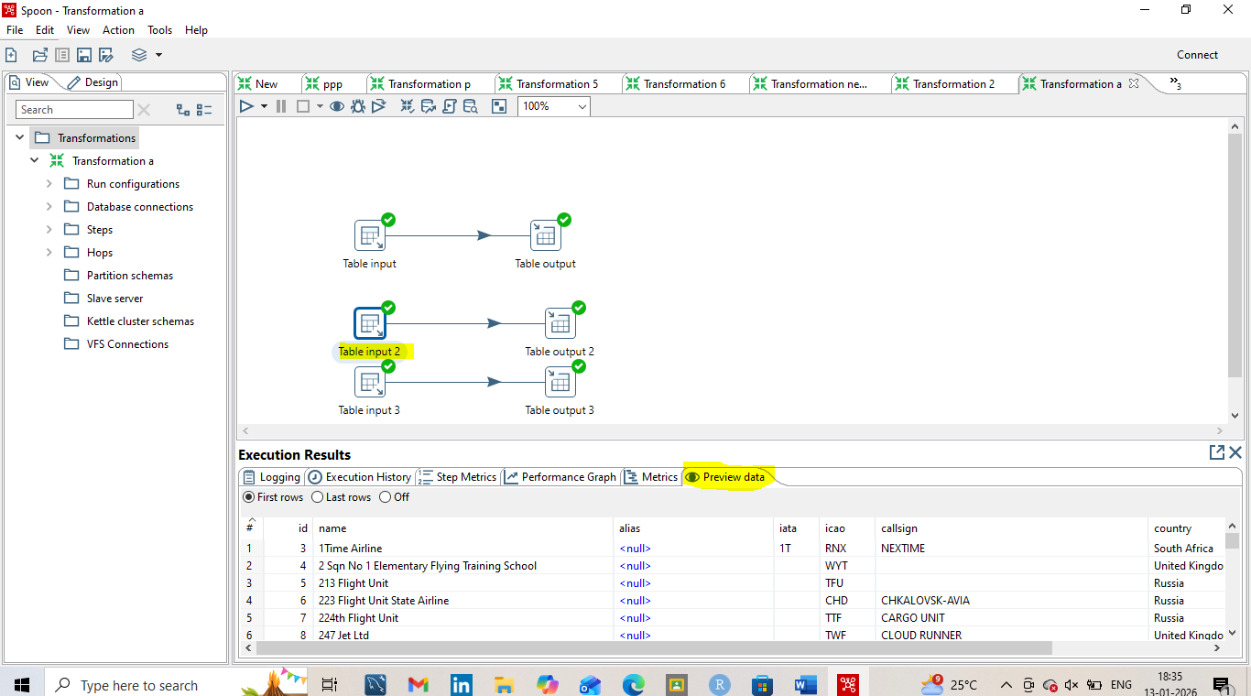
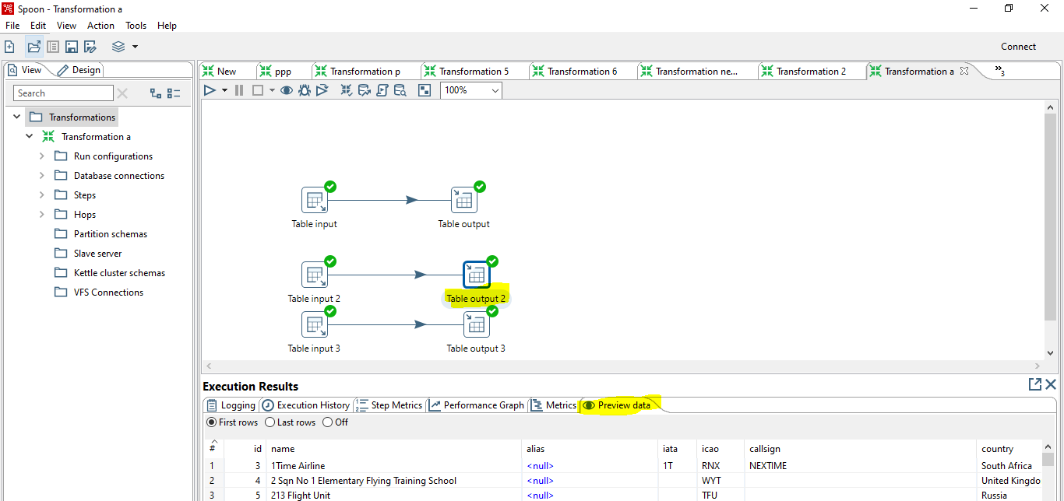
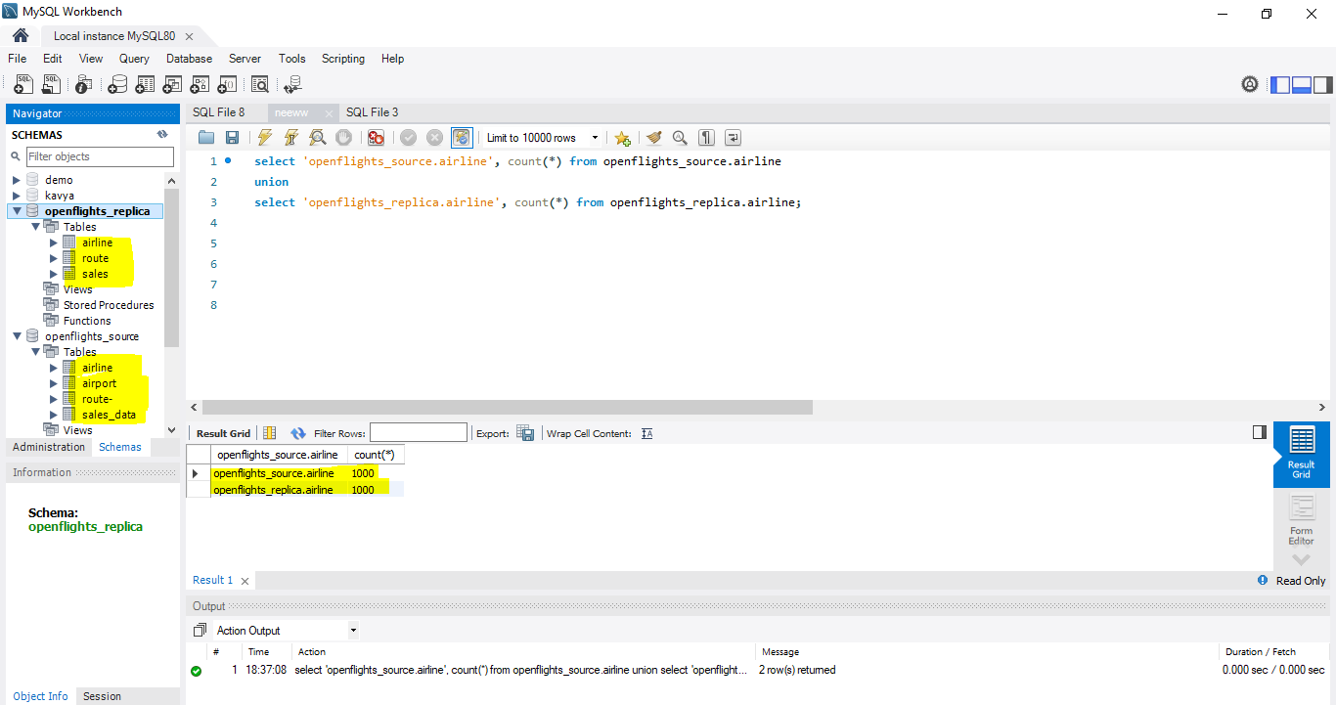
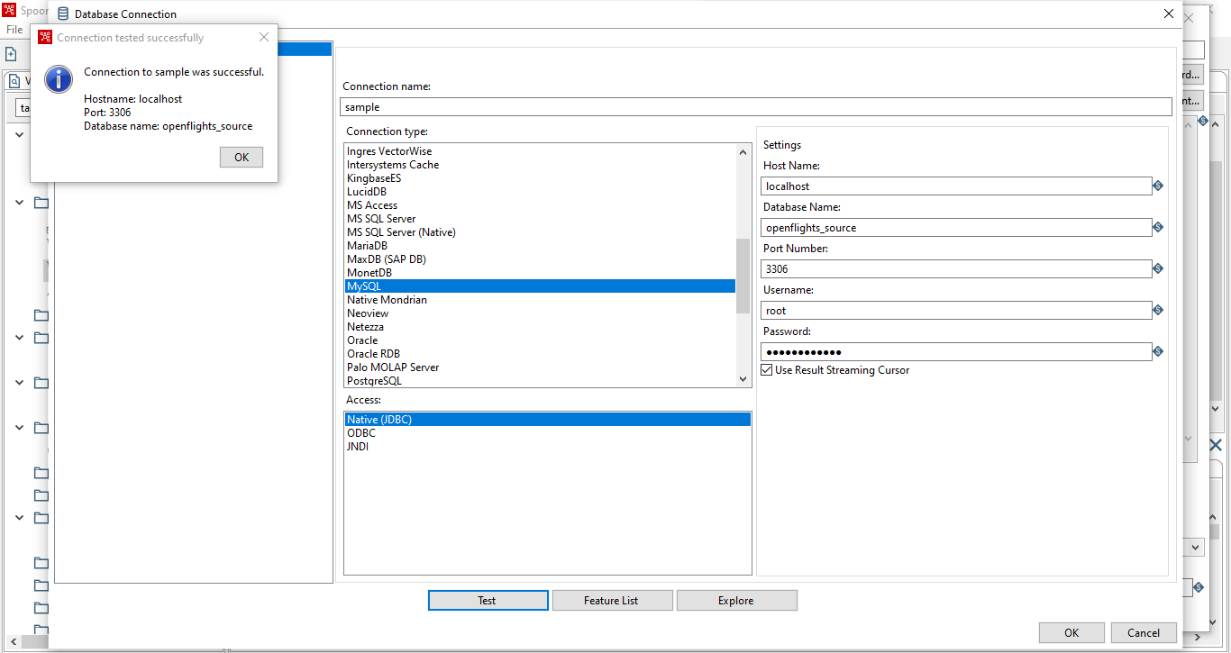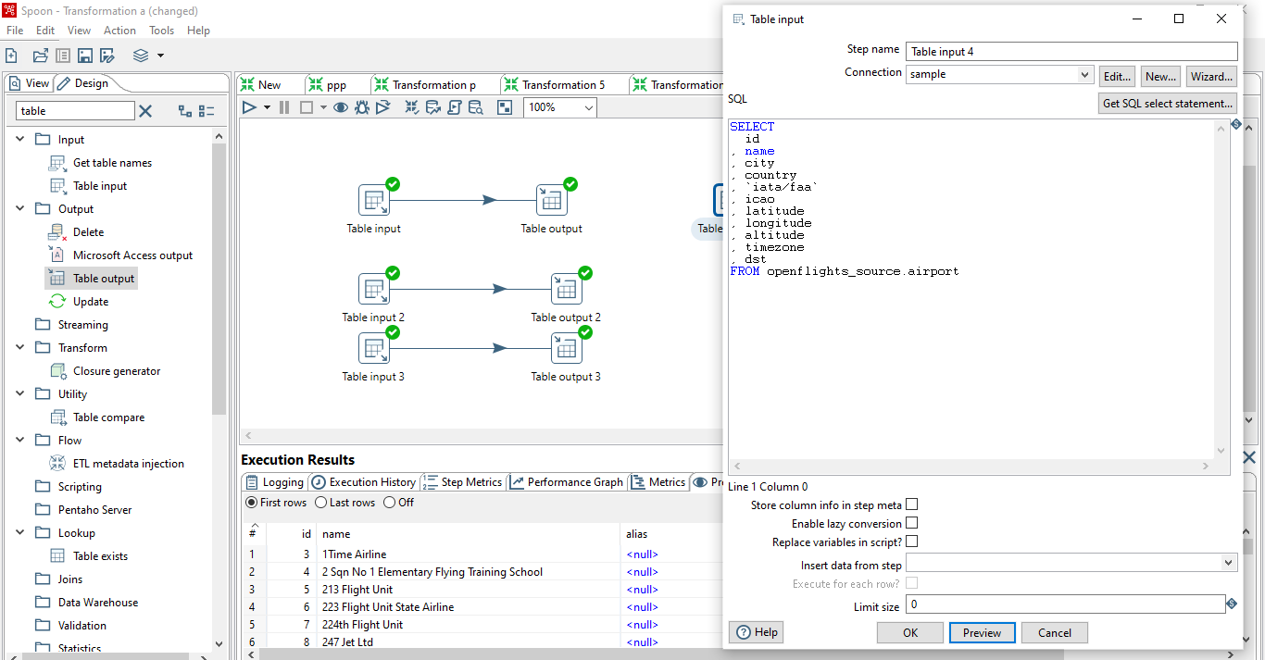
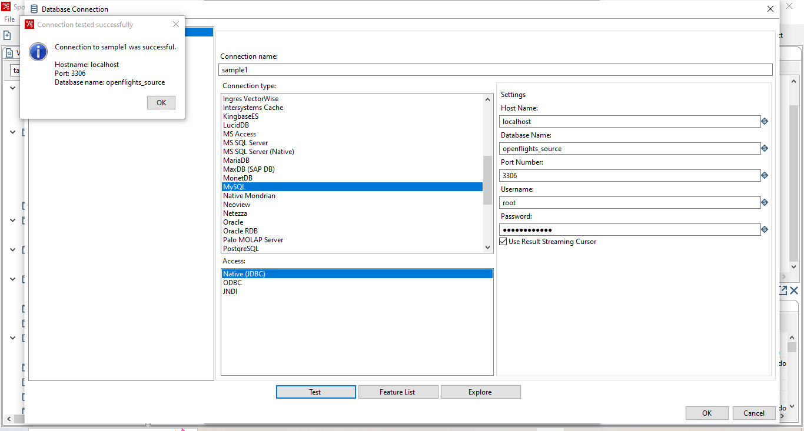
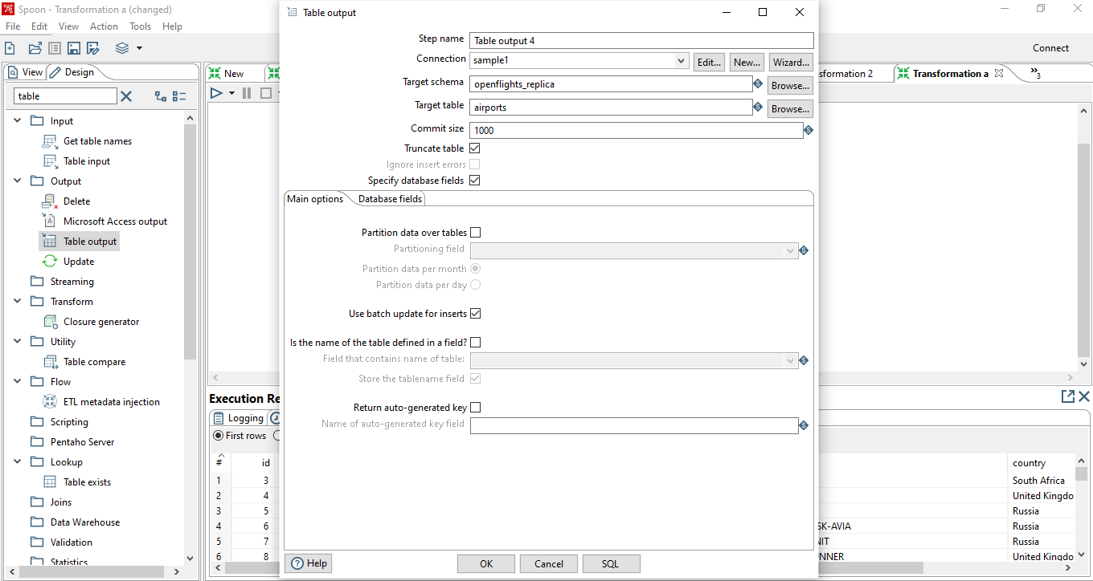
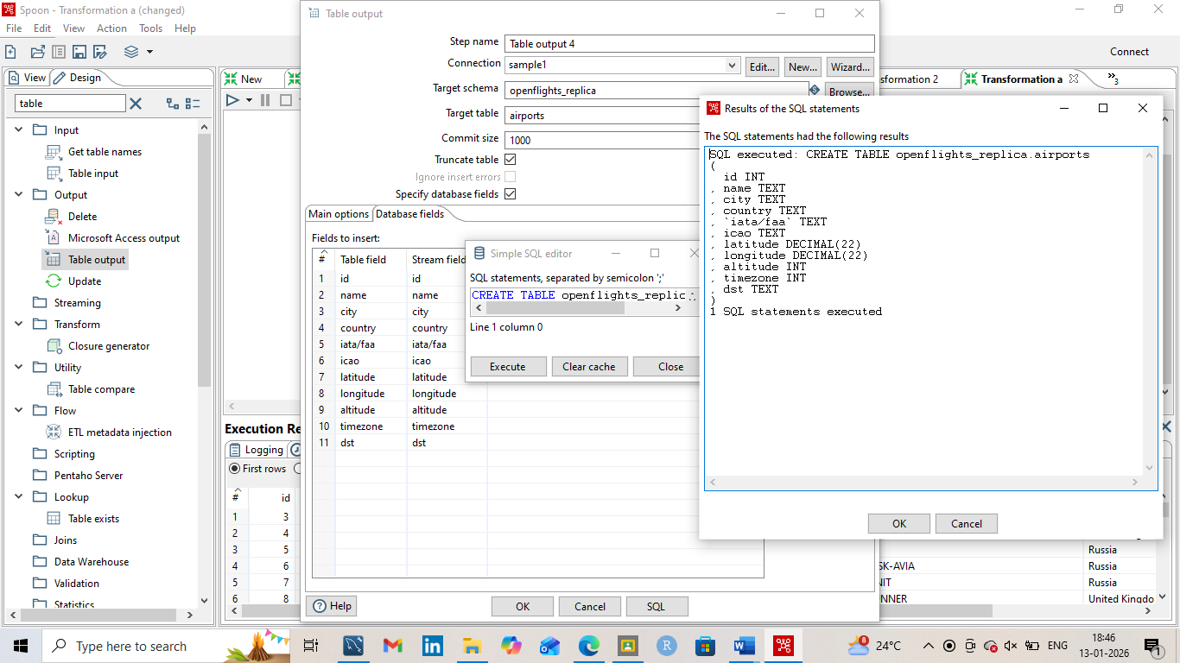
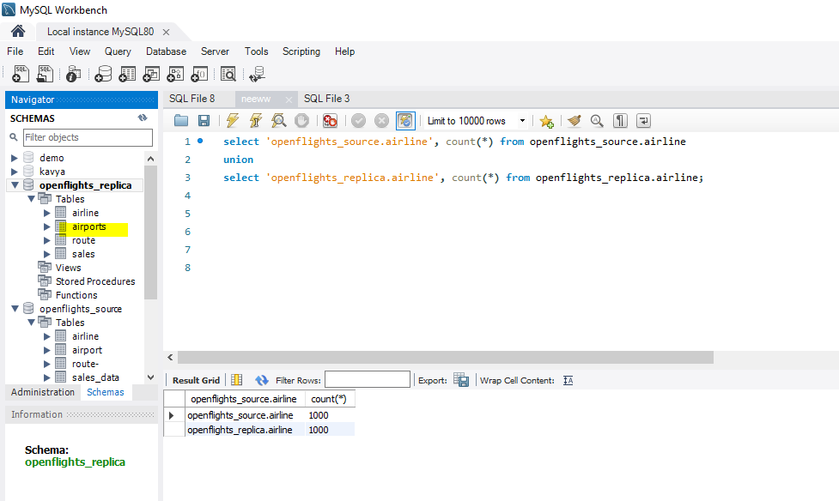

- Retrieve data from a CSV file and click preview rows to verify the file is being read correctly. (Use: Cust_dimension)

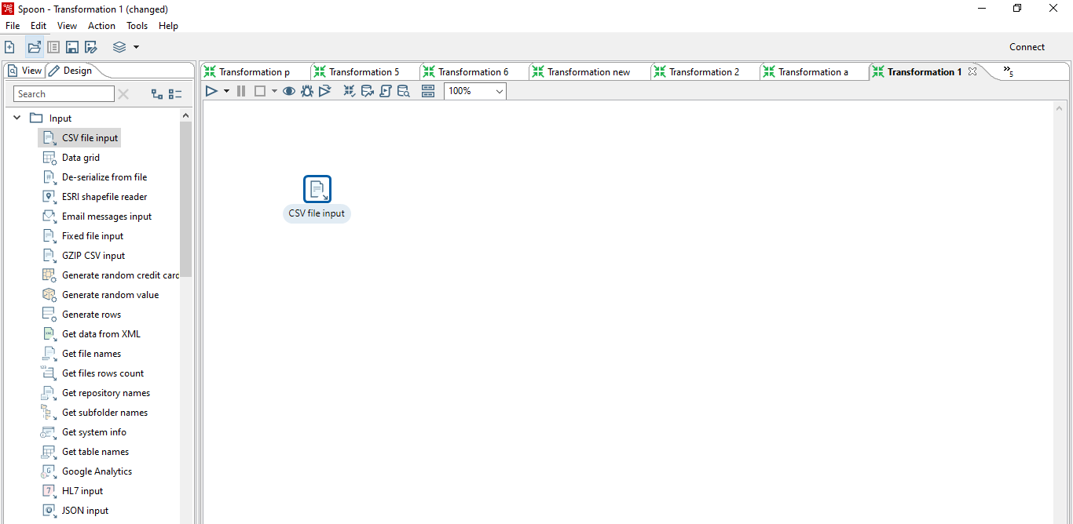
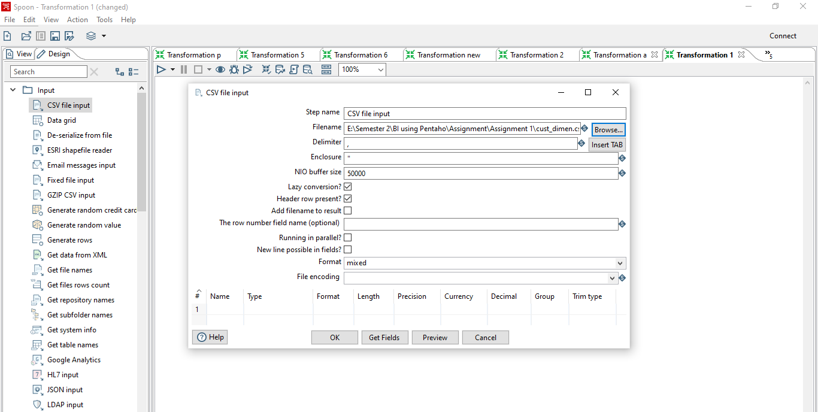
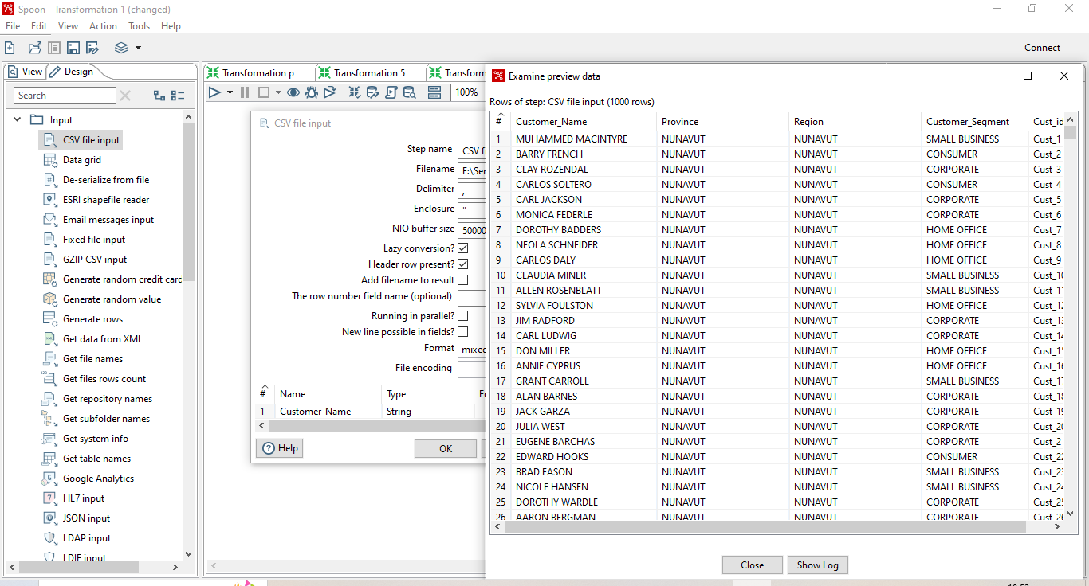

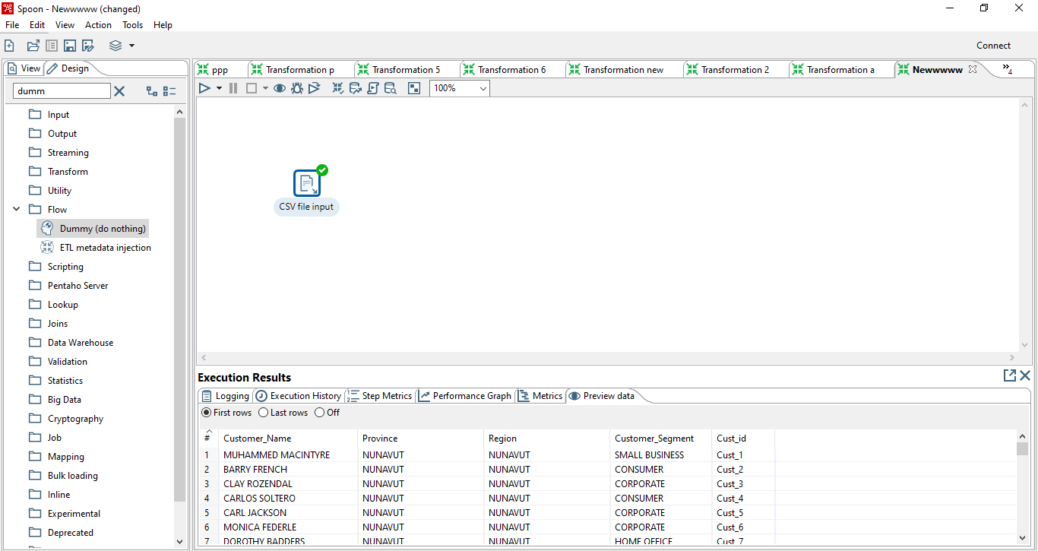

To obtain a data, use the following component.
  - Merge
  - Sort
  - Unique
